HOW TO REGISTER FOR COLLEGE VISITS – NAVIANCE STUDENT

- Click on the Colleges Tab

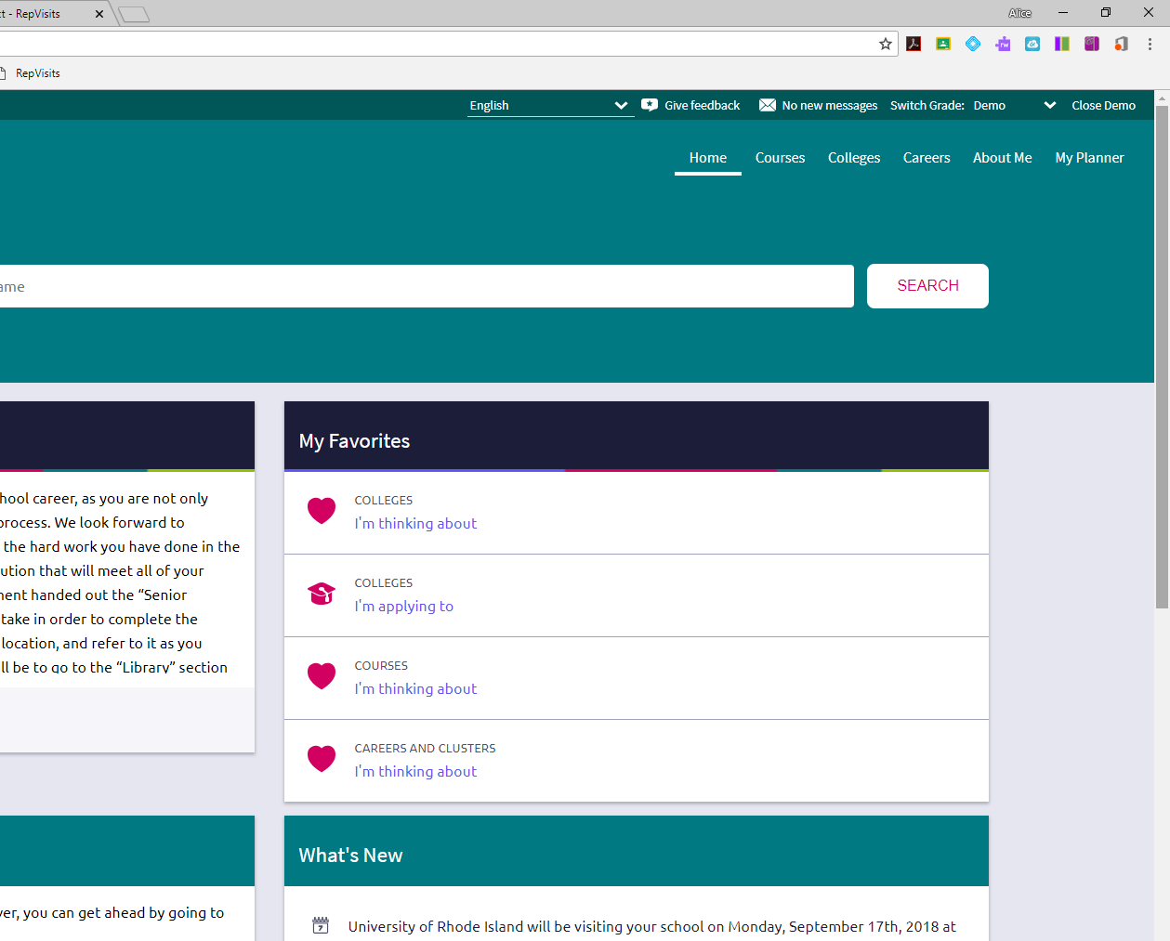

- Click on Research Colleges

- Click on College Visits

- Click on Register Now

- Click View Details

- PRINT THIS PAGE AS YOUR PASS!!!
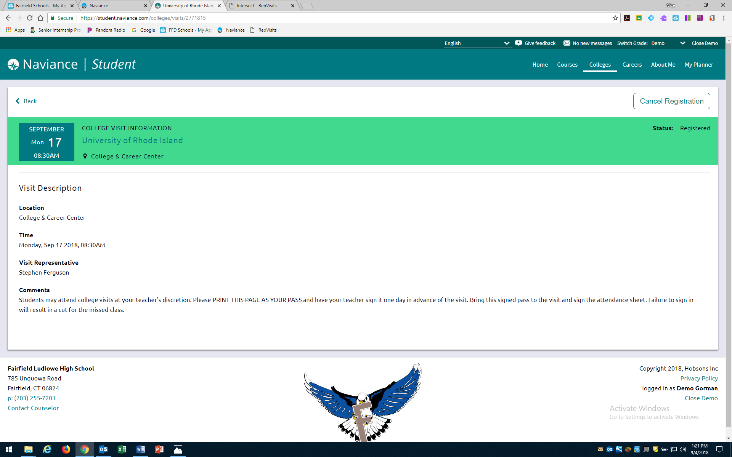

- Have your teacher sign it
- Bring the signed pass to the visit
- Sign the attendance sheet at the visit or you will get a cut for the missed class
- If you have a free period, YOU DO NOT need a pass, but YOU DO need to register on Naviance

